866 Yuhangtang Road

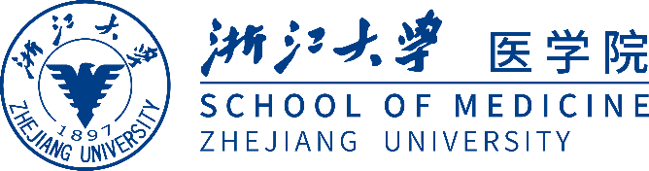Hangzhou 310058

Zhejiang China

Tel：+86-571-88208020

Fax：+86-571-88208022

Web：www.cmm.zju.edu.cn