Walkthrough to check your marks
Created by Osama Sajjad
Hi, for all of your ease and also for the community members ease I have written this guide to walk you through the steps to get your result. And it will also be a lesson in Chinese, lol, so bear with me.
The website to check your score is jwbinfosys.zju.edu.cn (henceforth referred as system website)
The website has two versions; one is the old boring version while the other is the new one which is cooler with pictures and much easier to get around in. One thing I found with Chinese websites is that they don’t have much compatibility with Mozilla’s Firefox and some of the scripts don’t work with it, so if you are a Firefox user and experience some problem then just try the same website in iexplorer and it’ll work. Any way the main page at the system website has two options for you, which is either to choose the new website or the old one and a 10 second counter to choose. After 10 seconds the website automatically re routes you to the new version (now this could be because I normally choose the new version so it re routes me to that website because if my memory serves me right the first time I waited it re routed me to the old version in the university) anyway this 10 second counter script does not work for Firefox so you will be stuck in that page until you select the version yourself.
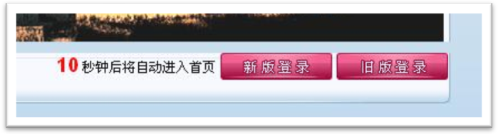
Now the left button reads “xin ban deng lu” and the right one reads “jiu ban deng lu”, meaning login to new version and login to old version respectively. Deng lu in Chinese means login so remember to recognize these characters and if you are up in a Chinese website that requires logging in then that’s what you look for. So click on the new version link and this is what you will see next,
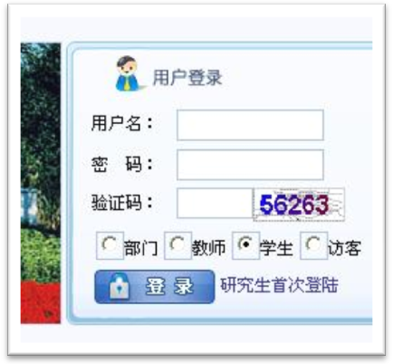
This will be in the right top corner of the page and here is what it says, the 用户名 is read yong hu ming and means username, and this is where you put your student number. The next is 密码 read mi ma and means password. If you all remember then by default all your passwords are 000000, more on changing passwords later. Next is 验证码 read yan zheng ma means verification number so just put the number you see in the area. Next just press 登录 cuz its already by default selected to student.
Cool you are in now and this is what you will see,
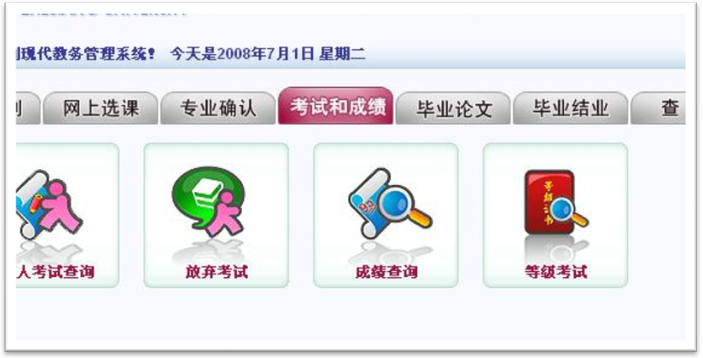
Actually you get this page by selecting the tab you see in red, by default the first tab would be selected so select the tab that reads 考试和成绩 read kao shi he cheng ji means exam and marks. There you will see the four buttons you see up here, I won’t bore you with telling what all of the buttons mean so we’ll just get to the important one, which as is obvious is the third one 成绩查询 read cheng ji cha xun and means inquire score. So click it and a new page opens which is like this
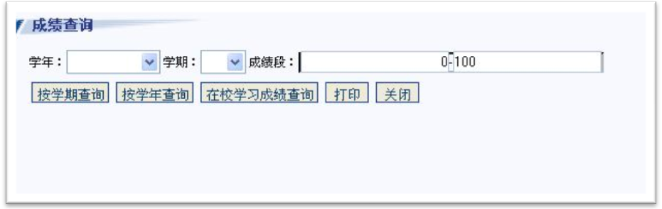
The first drop down is 学年 read xue nian means study year, the second is 学期 read xue qi means study term. The 5 buttons below from left to right are 按学期查询 read an xue qi cha xun means press for term score, next is 按学年查询 read an xue nian cha xun, 在校学习成绩查询 read zai xiao xue xi cheng ji cha xun means score from the time enrolled in the university, after that 打印 read da yin means print and the last is 关闭 read guan bi means close. Now if you want your total score for all the subjects then you don’t need to choose any thing just press 在校学习成绩查询 and it will give you a message with reference to a webpage but don’t worry its nothing, just press ok and it will show you your result for the whole time*. If you want to see the yearly score then select the respective study year from the 学年drop down menu and then click the 按学年查询 button press ok for the message and you will get your score. And if you want to see your term score then select the respective year from the drop down menu and then the respective term from the 学期drop down and press 按学期查询. The drop down menu is arranged from top to bottom as 秋 qiu, fall; 冬 dong, winter; 短 duan, short (probably means the break); 春 chun, spring; 夏 xia, summer. The fall and winter will always show the same result as it is set to show result for one semester regardless of the fact that you might have taken some subjects for just one term rather than for the whole semester. Same is the case for spring and summer.
* Note: This facility was provided to us starting the 2007-2008 year so you will only see your scores starting from this study year forward, I am not sure if ever the 2006-2007 year will be updated or not. So don’t worry if you cannot see the 2006-2007 score. Of course this only applies to the 2006 batch and the 2007 batch onwards will have all of their scores updated.
Also one more thing is just remembered, when you check your result for the first time there is a chance that it might give you a page with an option to choose and if I remember correctly there is only one option and if already selected so just press the button which would mean ok in Chinese and you are good to go. Now this may or may not turn up so I am just giving a heads up. It is not showing for me so I don’t have a picture or explanation.
Subject Key
Here is a list of the Chinese names of the subjects we have studied and their English translation
人体解剖学 ren ti jie po xue Anatomy
组织胚胎学 zu zhi pei tai xue Histology and Embryology
生物化学 sheng wu hua xue Biochemistry
医学遗传学 yi xue yi chuan xue Genetics
生理学 sheng li xue Physiology
汉语语法和精读 han yu yu fa he jing du Chinese grammar and intensive reading it starts with I, II and so on which is levels for each semester.
汉语听说 han yu ting shuo Chinese listening and speaking, again has levels for each semester
医学免疫学 yi xue mian yi xue Immunology
病原生物学 bing yuan sheng wu xue Microbiology and Parasitology
病理生理学 bing li sheng li xue Pathophysiology
病理学 bing li xue pathology
法医学 fa yi xue Forensic Medicine
药理学 yao li xue Pharmacology
These are the subjects that are relevant for the first two years I did not add biostatistics as the juniors will not study it and our scores of first year are not updated yet, for more subjects as you all proceed on with your studies you can ask your teachers, or by that time you will know the names yourself.
Changing the password
Now security is a big issue and it’s easy to see any ones score by default if you know their student card number as the password by default is 000000. So for those who want to change their passwords then read on, the main page you went to after entering your user name and password has three options in the right top corner looking some thing like this,
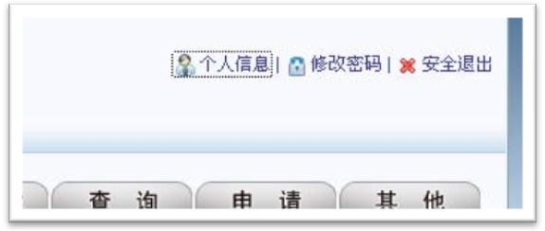
Left to right is 个人信息 ge ren xin xi meaning Personal information, next is 修改密码xiu gai mi ma means change password and last is 安全退出 an quan tui chu means safe log out. Press the middle one and it gives a new page looking like this,
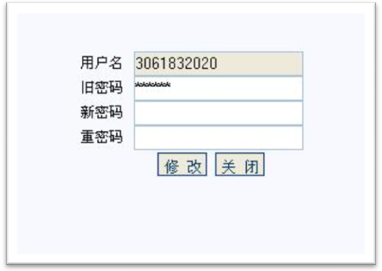
As told before the above is 用户名 or username, next is 旧密码 jiu mi ma means Old Password, after that is 新密码 xin mi ma new password and last is 重密码 chong mi ma means repeat new password. The two buttons below are 修改 xiu gai and 关闭 already covered before meaning change and close respectively. So change your password by filling in the required fields and then press change, and you are good to go.
If you have any more information that you need to ask or problems that need troubleshooting then contact me at darkbayinc@gmail.com.

Take care and be safe.

