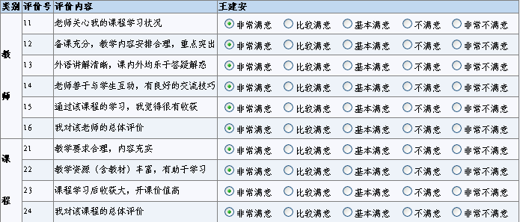
Teacher Evaluation Sheet
Teacher | Commentary | Satisfactory from 5 (highest) ~1 (lowest)
Teacher | The teacher cares about my course condition | 54321
Teacher | Well prepared, well arranged, empathized | 54321
Teacher | Using understandable English, willing to answer the questions in and out of class period | 54321
Teacher | Good communication skill | 54321
Teacher | I gain some new knowledge after the course | 54321
Teacher | Overall evaluation | 54321
Course | Reasonable course requirements, enriched content | 54321
Course | Teaching resources (course book) helps the study | 54321
Course | The course is worth to have | 54321
Course | Overall evaluation to the course | 54321

请您对提高该教师该课程的教学质量提供宝贵意见和建议（限100字，可不填）：
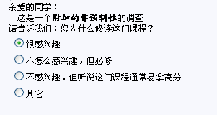
Your advice to help improve the teaching quality of the course (no more than 100 words, not mandatory)
课堂外语授课比例：
  30%以下 | 30%-70% | 70%以上

What is the percentage in the class that the teacher use English?
Lower than 30% 30%~70% More than 70%
Why did you choose this course?
- I am very interested in it.
- I am not very interested in it, but it is mandatory.
- I am not interested in it but I think it is an easy course.
- Others.

