Excellence in Clinical Research Training (Excel-CRT)

The University of Pittsburgh School of Medicine

Institute for Clinical Research Education

2019

Introduction
To provide training in the knowledge and skills necessary to conduct high-quality clinical and translational research, the University of Pittsburgh’s School of Medicine and its renowned Institute for Clinical Research Education (ICRE) is proud to offer the Excellence in Clinical Research Training (Excel-CRT) program, a competency-based, hybrid training program.

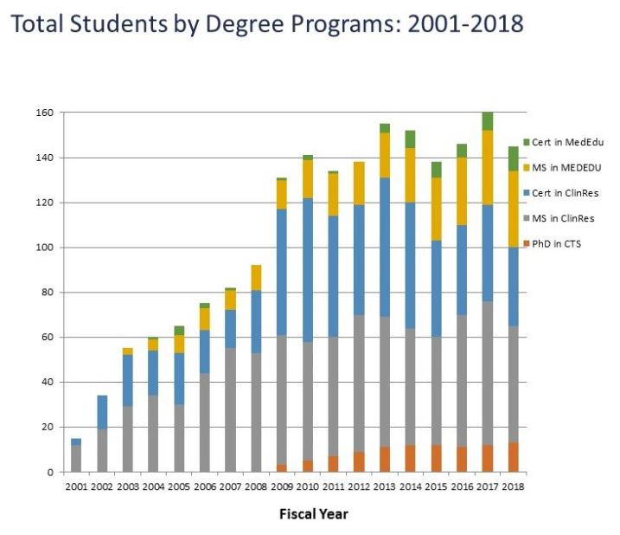
ICRE
The ICRE has seven degree programs in clinical and translational research, 12 career development programs, and has collectively trained more than 1,000 investigators at all career stages (Figure). There are more than 300 students currently enrolled in ICRE courses, and the core teaching faculty represents all six of the University of Pittsburgh Schools of the Health Sciences.

Partnering with the ICRE’s Innovative Design for Education and Assessment (IDEA) Lab under the directorship of Marie Norman, PhD, the ICRE is moving some of its most popular courses and programs online to create more flexible learning options for students in the Excel-CRT program. ICRE uses research-based learning principles to ensure that its online courses are as rich, rigorous, and engaging as the face-to-face courses.

Housed within the ICRE, the Center for Research on Health Care’s Data Center has been the go-to solution for University of Pittsburgh researchers. The Data Center has a talented team of faculty and staff members who provide high quality statistical analysis, database development, programming, website design, and other graphic design services. With more than 500 research projects in their portfolio, the Data Center offers deep statistical and technological expertise.
The ICRE’s established reputation for high-quality education and training, its stellar faculty, and the resources of the IDEA Lab and Data Center make it a collaborative learning opportunity for clinician-led research and an ideal home for the Excel-CRT program.

Excel-CRT: Research Fundamentals
Excel-CRT is designed as a three-month program for medical students, residents, postdoctoral fellows, and junior faculty interested in clinical research. In the first two months of the program, scholars take Research Fundamentals, a set of intensive courses that provide a foundation in clinical research study design, statistical methods, measurement, and computer methods. All courses are taught by instructors chosen for their deep subject matter expertise and strong teaching skills. They are taught in a hybrid format to capitalize on the advantages of both online and in-person learning. The courses are as follows:
- Computer Methods in Clinical Research: In this course, trainees learn how to use software to manipulate data, graphically represent data, and statistically analyze data. Database construction and good data management practices are also emphasized. Competencies addressed: Data quality and characteristics, data security and management plans, protecting privacy, organizing datasets, applying statistical techniques, organizing statistical results, protection of human research participants.
- Clinical Research Methods: This training provides an overview of the basic research strategies, methods, and goals of clinical research. It covers three main clinical research methodologies: (1) clinical trials, (2) epidemiology, and (3) evidence-based medicine. Topics include study design, specifically clinical trials and epidemiology, data analysis and interpretation, and determination of appropriate methodologies to answer different research questions. Competencies addressed: Formulating research questions, reviewing other studies, conducting literature reviews, understanding study designs, identifying study populations, recruiting study participants, being on a multidisciplinary team.
- Applied Biostatistics: In this intensive course, trainees learn basic statistical concepts and methods and their application to problems in health and the biomedical sciences. Topics include data description and summarization, basic probability theory, estimation, and hypothesis testing, with emphasis on one-, two-, and multi-sample comparisons using continuous and categorical data. Competencies addressed: Formulating hypotheses, understanding study design, reliability and validity, organizing datasets, formulating data analysis plans, applying statistical techniques, organizing and interpreting statistical results.
- Measurement in Clinical Research: Trainees in this course learn the properties of good measurement practices that are integral to the research process. Specific objectives are to analyze methods for testing reliability and validity, evaluate the adequacy of selected scaling methodologies used in clinical research, apply knowledge of instrumentation in grant applications, and synthesize statistical criteria for evaluating scales. Competencies addressed: Reliability and validity, data quality characteristics, data analysis plans, applying statistical techniques, working in multidisciplinary teams, engaging in self-assessment.

Excel-CRT: Applying Best Practices in Clinical Research
The ICRE builds upon its well-established competency-based education model, which emphasizes the learner’s demonstration of concrete, measurable skills, in order to integrate experiential learning across its research training programs. To incorporate this experience, the Excel- CRT program includes a third month focused on application of best practices in clinical research. During this month, scholars will have the following opportunities:
- Clinical Research Seminar Series: Scholars will meet regularly with clinical investigators at different career stages and receive group mentoring from an experienced investigator on key stages of study design.
- Study Design “Bootcamp”: The ICRE has designed a four-week immersion experience delving into the key aspects of study design. Scholars will be led through a review of a seminal study. They will then apply a similar thought process in working through individual projects. Scholars will be expected to draw upon what was learned in research fundamentals to demonstrate competency in forming a research question, approaching a literature search, creating study aims, and developing a methods section for their respective projects.
- Running a Clinical Research Study: In this course, scholars will receive guidance on research study implementation, including study start up, navigating the institutional review board, creating a manual of procedures, managing data, and managing personnel.
- Responsible Conduct of Research (RCR): Ethical standards and responsible practices are the context for successful scientific research. At any step in the research process, scholars may need to address ethical issues in a thoughtful, responsible manner. The CTSI Responsible Conduct of Research (RCR) Center serves as a resource for researchers at the University of Pittsburgh. Their objective is to provide education so that researchers learn to effectively recognize and avoid research misconduct. This RCR Center seminar series is held weekly for one hour. The new RCR workshops offered in program year 2018 included: P-Hacking: Lessons from the Brian Wansink scandal, Social Media in Research, All Journals Are Not Created Equal, How the NIH Can Help You Get Funded, Ethical Marketing of your Research Study, and Securing Your Digital and Paper Data.
- IRB Observation: Human Research Protection Office (HRPO) staff members are committed to providing support and guidance to the research community, as well as ongoing support and advice on issues that arise during the conduct of research. HRPO also oversees the functions of the Institutional Review Board (IRB). The primary purpose of the IRB is to protect the rights and welfare of human participants involved in research activities being conducted under its authority. The Excel-CRT program provides scholars with the opportunity to meet with an IRB review board member and observe one of the committees in a live review session.
- Health Sciences Research Seminar: The Health Services Research Seminar Series is sponsored by the Center for Research on Health Care, VA Center for Health Equity Research and Promotion, and RAND-University of Pittsburgh Health Institute. Excel-CRT scholars will join this one hour, weekly seminar featuring national thought leaders presenting their work in various fields of health sciences research.
- Career Development Seminar: ICRE will also offer a variety of customized career development sessions to Excel-CRT scholars. They will participate in four one-hour informal presentations where they will hear experts speak about (1) developing and managing a research team, (2) creating a poster presentation, (3) creating and maintaining large databases, and (4) preparing a manuscript. In this final section, scholars will learn how to quote and paraphrase other scholars appropriately to avoid accusations of plagiarism. Following the presentations, the scholars will have opportunity to engage in lively dialogue with the speakers and to ask questions.

Through the foundational Research Fundamentals courses and the experience in applying best practices in clinical research, the Excel-CRT program builds on the ICRE’s long history of high-quality clinical research education. It emphasizes the multidisciplinary nature of clinical and translational research and focuses on applied approaches and practical skill-building, providing trainees with the skills required for clinical investigators in all fields of interest. Scholars who complete the three-month program will receive an ICRE-conferred certificate of completion.

